**Module 3 Lesson #5: The Cosine Function**

**and Periodic Applications**

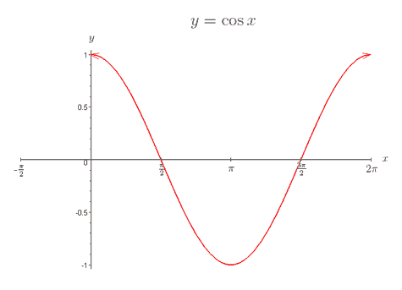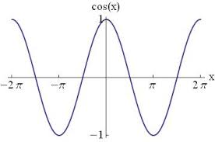

**Learning Targets**

I can draw one cycle of the parent cosine function $y=cos x,$ and know it has a period of $2π$ and amplitude of 1.

I can draw one or more cycles of a transformed cosine function $y=a cos bx+d,$ and identify the period as $\frac{2π}{b}$, the amplitude as $\left|a\right|$ and the midline as d. I can recognize when the graph is reflected over the x-axis and understand why.

I can write the equation of a cosine function in the form $y=a cos bx+d,$ given the amplitude and period.

I can determine the number of cycles that will occur in $2π$ radians.

I can model periodic functions in real life situations.

**The Cosine Function**

|  |  |  |  |  |  |
| --- | --- | --- | --- | --- | --- |
|  | 0o | 90o | 180o | 270o | 360o |
|  |  |  |  |  |  |

What is the relationship between $y=sinx$ and $y=cosx$?

$$y=acosbx+d$$

***Example 1:*** Graph one cycle of $y=2cos3x$

***Example 2:*** Graph one cycle of $y=-3cosx$

What is the domain and range of this cycle?

***Example 3:*** Graph $y=2cos2θ$ from $[0,2π]$

**Example 4:** Graph $f(x)=-3cos\frac{θ}{2}$ from $[0,2π]$

**Example 5:** Graph one cycle of $y=5cos\frac{π}{3}x-3$

**Writing the Equations of Cosine Functions**

**Example 1:** Sketch one cycle of a cosine curve with an amplitude of $2$ and a period of $\frac{π}{2}$. Write the equation of this curve.

**Example 2:** Find the period for each of the cosine curves below. The write an equation for each function, given the interval $[0, 2π]$

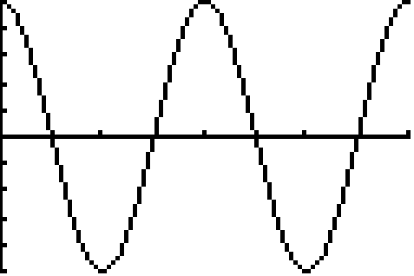**Function A**  **Function B**

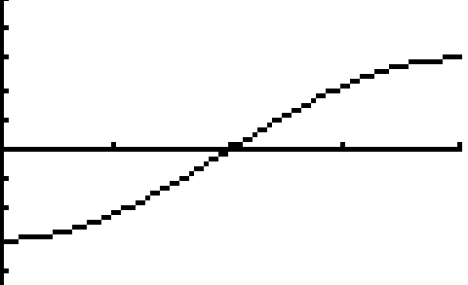

**Applications**

**Example 1:** A base of a Ferris wheel at Darian Lake is one foot above the ground. Draw a labeled sketch of one cycle of the car on the wheel that starts in the 6 o’clock position if the radius is 30 feet.

**Example 2:**

The height above the ground of a person riding a Ferris Wheel can be modeled by the function $h(t) = 30 – 28 cos \frac{π}{24}t$, where h is the passenger’s height in feet and t is the time in seconds since the ride began. Graph one cycle of this scenario.

What is the initial height of the passenger?

At what time does the passenger reach the top of the Ferris Wheel? What is his height now?

How long does it take the passenger to complete one full rotation?